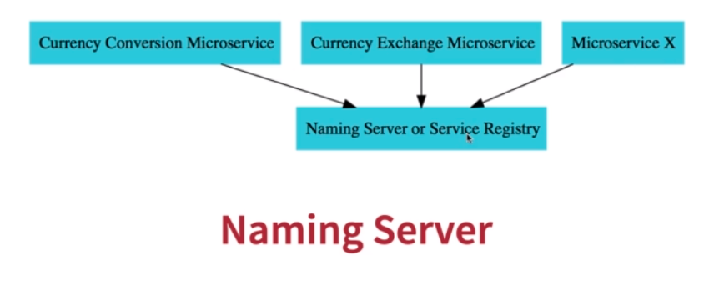
All our apis(all instances) would register with a naming server. Eg if Currency conversion api need to talk with exchange service, it would ask naming server about the address of the currency exchange service.

Client Side Load Balancing :

Provided by Eureka. Previously provided by Ribbon.
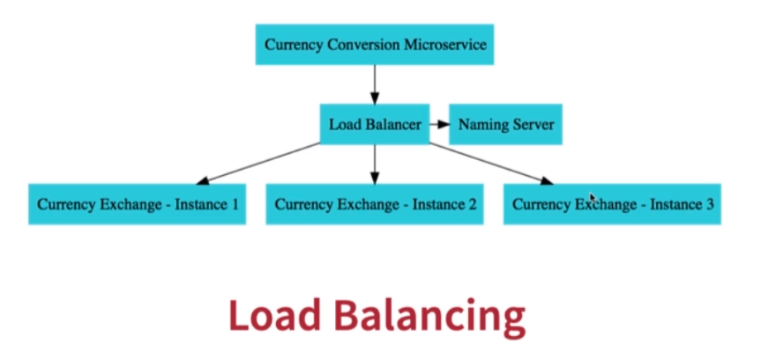
Apart from consuming REST services in an easy way, FeignClient/OpenFeign when combined with Eureka also offers us an easy load balancing.

